Grant Alerts from ACET, Inc.

ACET, Inc., has created a web-based grant alert tool that’s constantly updated in real time where you can access grant opportunities that ACET finds for organizations like yours. ACET identifies hundreds of funding opportunities every year from foundations, federal agencies, state agencies, counties, and other funding sources for nonprofit organizations, schools, government agencies, and tribal organizations.
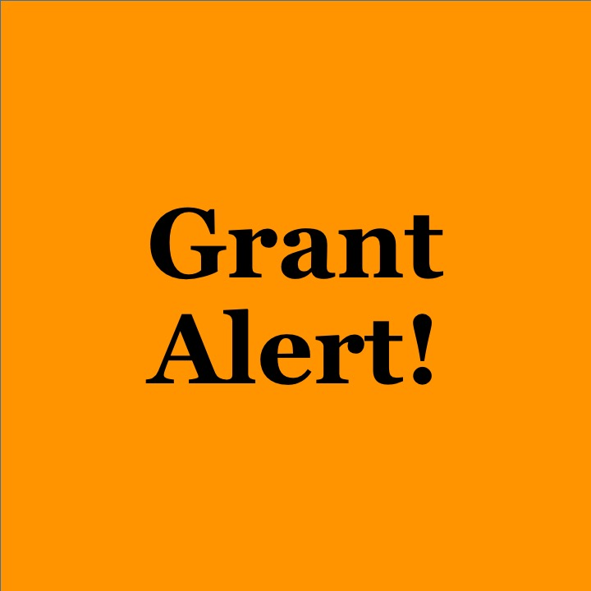
Visit the List of Grant Opportunities
Find the list at:
https://www.acetinc.com/grant-alert

Each grant alert includes the following information:
- Funder (name of funder)
- Focus
  - Arts/Culture
  - Community Development
  - Cultural Heritage
  - Education
    - Early childhood education, public school education, private school education, higher education, etc.
  - Environmental Sustainability
  - Health
  - Human Services
    - Child care, families, housing, mental health, people with disabilities, refugees, tribal administration, youth development, etc.
  - Nonprofit Management
- Type
  - Federal
  - State
  - County
  - Foundation
  - Private Donor
  - Other
- Amount (dollar amount of the funding opportunity)
- Due Date (either the due date of the Letter of Intent (LOI) or the proposal due date)
- Hyperlink (link to the funding opportunity)
- Evaluation Required (invite ACET to do the evaluation portion of your application)
- Attachment (any documents from the funder about the grant)

Search Grant Alerts
In the link, consider searching for information by:
Changing the view. Grid view gives you the entire list. Card view separates them by type. Calendar view shows you grants by due dates.
Using a filter. Click to the right of Grid view. Click on: The filter you wish to use. Or click on: New Filter. Select the field and create the filter. Apply. Click on: Filter off to remove it.

Questions?
Visit the list at: https://www.acetinc.com/grant-alert. Or contact Jolene Roehlkepartain, Communications Editor at ACET, who manages the Grant Alerts tool. Contact Jolene@acetinc.com or by phone at 952.922.1811.

